**Problem Statement 3 : Daily Scrums : EverNote Automation**

Every Monday : Praneet (CEO Of the company) Wants to automate the process of making the To do list, so he wants to make sure that he can say it to Alexa and it adds it to Evernote and make a common list for everyone

**Solution →**

Step 1 : Understanding

Requirements:

IFTTT Account,

Amazon Alexa App and Its Account,

Evernote Account,

Step 2 : Ideating

We need to Connect Amazon Alexa App and Evernote Account through IFTTT Applet.

Step 3 : Implementing

Open IFTTT website Click on create.

And Follow steps as shown below.

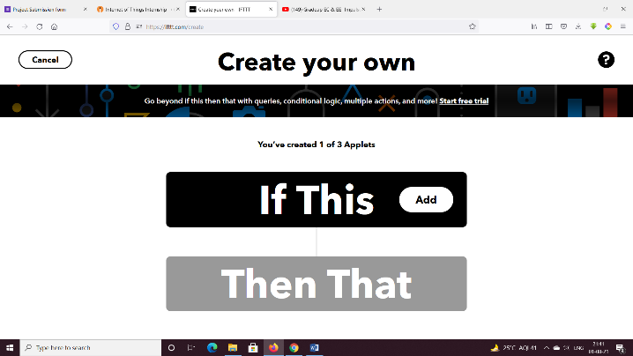

* Create Evernote Account

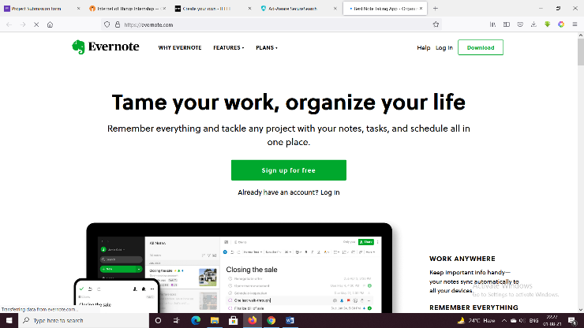

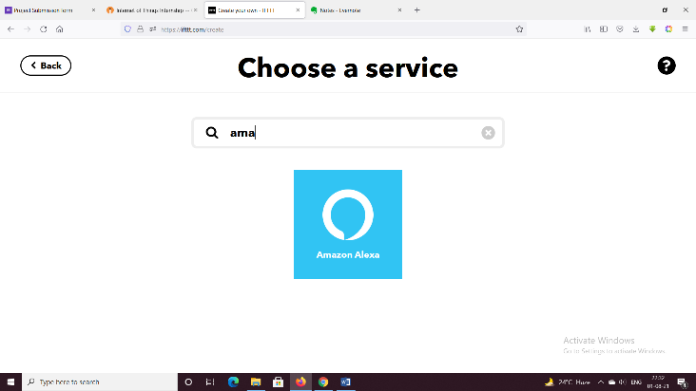

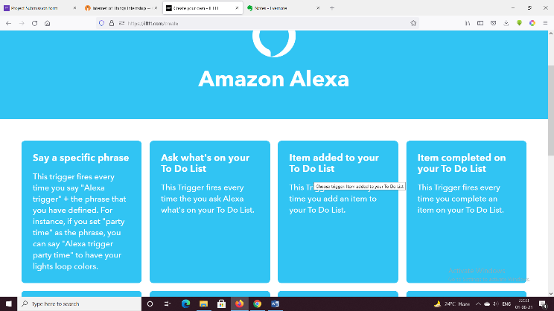

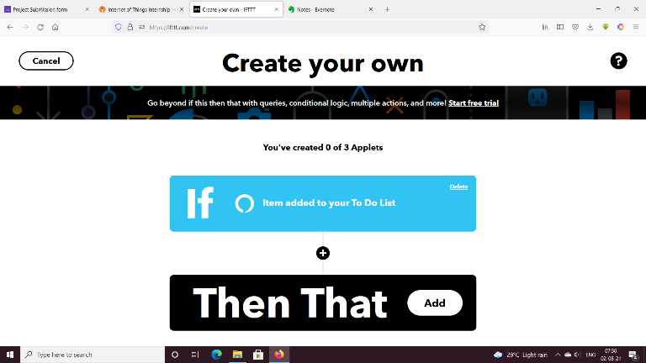

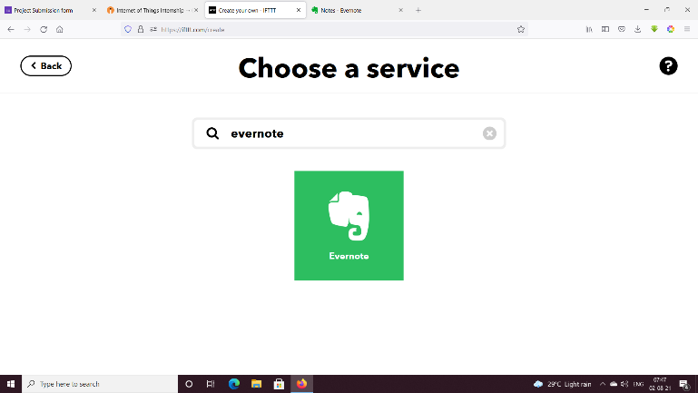

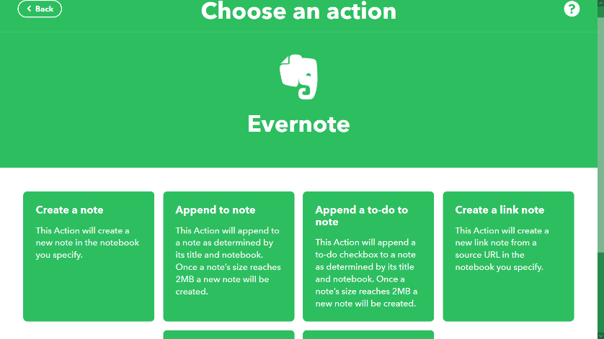

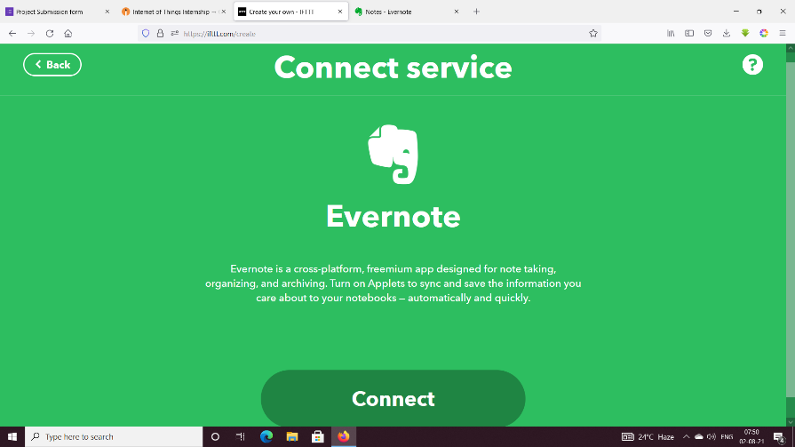

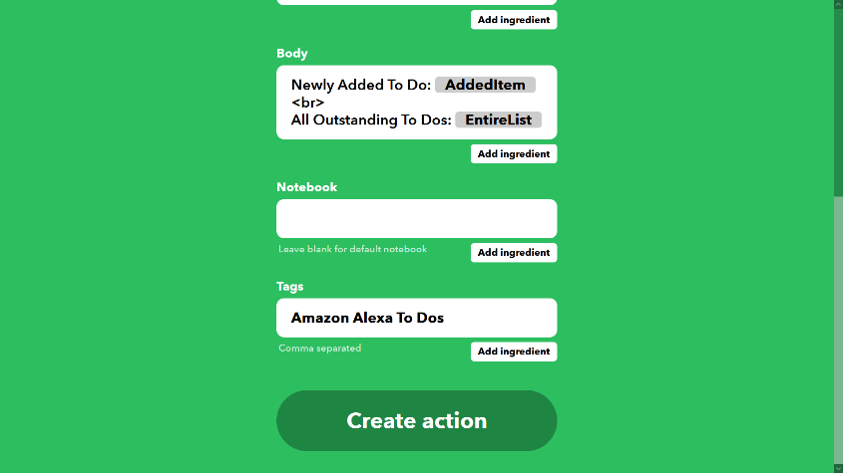

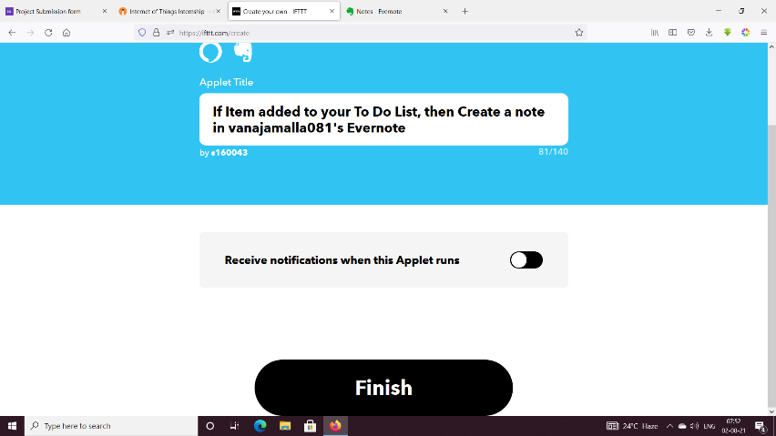

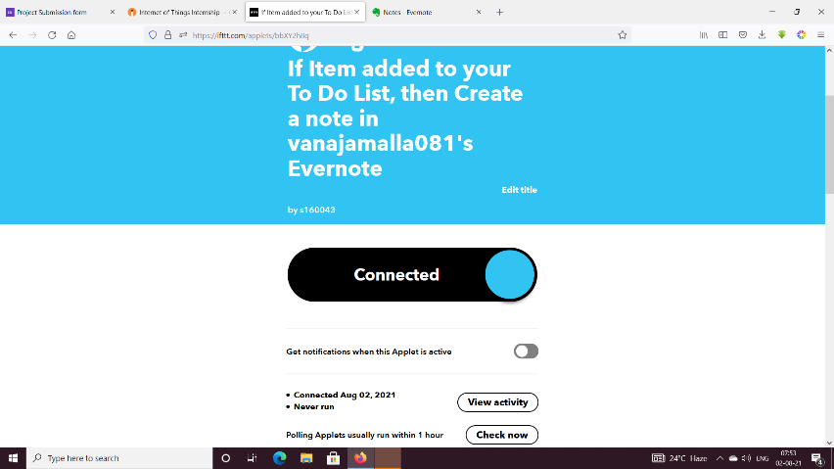

Step 3 Final Check:

